1. Which are the top three variables in your model which contribute most towards the probability of a lead getting converted?

Followings are top features that contribute to decision which mean the conversion probability of a lead increases with increase in values of these features:

* 1. Lead Origin
  2. Last Notable Activity
  3. Last Activity
  4. What is your current occupation

Reviewing coefficient of these variables indicate the importance of these variables.

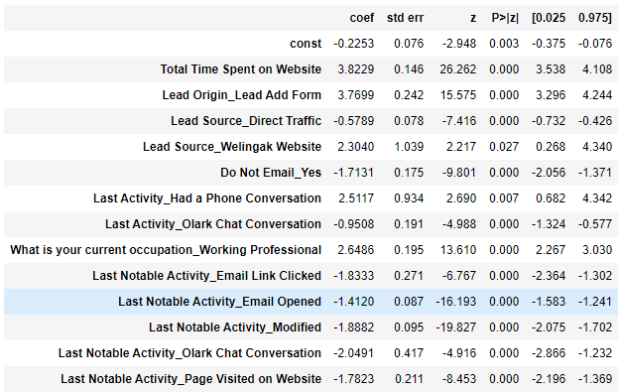

1. What are the top 3 categorical/dummy variables in the model which should be focused the most on in order to increase the probability of lead conversion?

After reviewing the final model and as evident from EDA as well, followings are the top 3 categorical variables in the model which should be focused the most on in order to increase the probability of lead conversion:

* + Lead Origin ==> Lead Add Form
  + Total Time Spent on Website
  + Lead Source_Direct Traffic

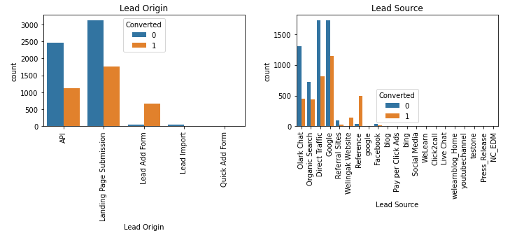

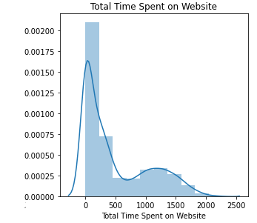

1. X Education has a period of 2 months every year during which they hire some interns. The sales team, in particular, has around 10 interns allotted to them. So during this phase, they wish to make the lead conversion more aggressive. So they want almost all of the potential leads (i.e. the customers who have been predicted as 1 by the model) to be converted and hence, want to make phone calls to as much of such people as possible. Suggest a good strategy they should employ at this stage.

* Sensitivity and specificity are inversely proportional, meaning that as the sensitivity increases, the specificity decreases and vice versa.
* Sensitivity with respect to our model can be defined as the ratio of total number of actual Conversions correctly predicted to the total number of actual conversions.
* Specificity can be defined as the ratio of total number of actual non-conversions correctly predicted to the total number of actual non-conversions.
* Different values of the sensitivity and specificity can be achieved for the same model by changing the conversion probability cutoff threshold value.

As per our model, the below graph shows how the Accuracy, Sensitivity and Specificity rating changes with change in the threshold value:

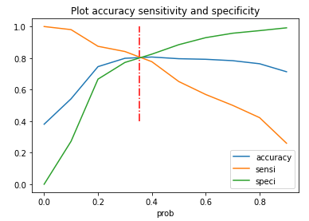

When the probability thresholds are very low, the sensitivity is very high and specificity is very low. Similarly, for larger probability thresholds, the sensitivity values are very low but the specificity values are very high.

High sensitivity implies that our model will correctly identify almost all leads who are likely to convert. It will do that by over-estimating the conversion likelihood, i.e. it will misclassify some non-conversion cases as conversions. Now, since X Education has more manpower for these 2 months and they wish to make the lead conversion more aggressive by wanting almost all the potential leads, we can choose a lower threshold value for Conversion Probability. This will ensure the Sensitivity rating is very high which in turn will make sure almost all leads who are likely to Convert are identified correctly and the agents can make phone calls to as much of such people as possible. The company may follow high volume low margin strategy which means the conversion rate might reduce but, the count of conversion would increase and eventually the revenue would also increase.

1. Similarly, at times, the company reaches its target for a quarter before the deadline. During this time, the company wants the sales team to focus on some new work as well. So during this time, the company’s aim is to not make phone calls unless it’s extremely necessary, i.e. they want to minimize the rate of useless phone calls. Suggest a strategy they should employ at this stage.

It is always best to practice to have alternate approach to yield our result. As per our final observation, High Specificity implies that our model will correctly identify almost all leads that are not likely to convert. Sometimes, it will dilute the Conversion rate which is risky.

Let us consider, If X Education has already reached its target for a quarter and doesn’t want to make phone calls unless it is extremely necessary, i.e. they want to minimize the rate of useless phone calls. Just increase the threshold value for Conversion Probability. Which ensure the Specificity rating is very high and in turn will make sure almost all leads who are on the threshold of the probability of getting Converted or not. Finally, Sales team won’t have to make unnecessary phone calls and can focus on some new task such as feedback collection from existing student, explore strategy for new courses, placement, etc. In this way the efficiency of sales team would increase as the conversion rate would be high. The sales cycle will also be reduced.